**Coding Challenge: E-Commerce Product Management using Redux & .NET Core API**

**Display Products from API**

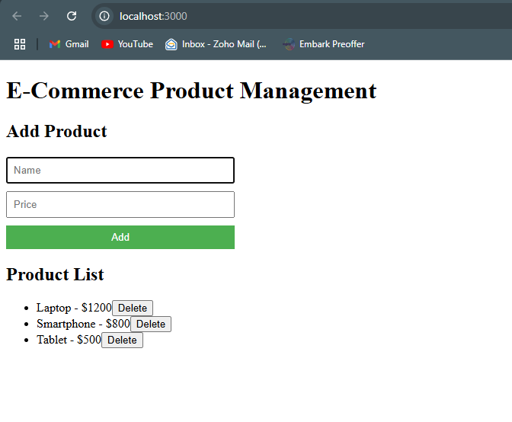

**Add a New Product**

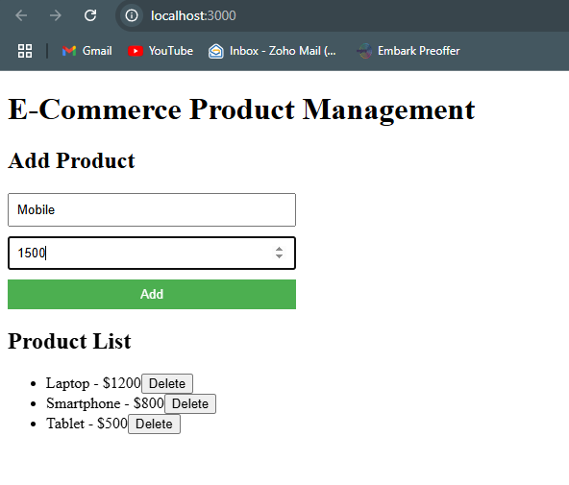

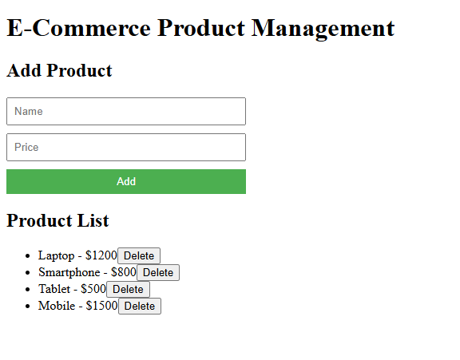**Delete a Product**

